Workflow Acquisition in LAS-X: Quickstart
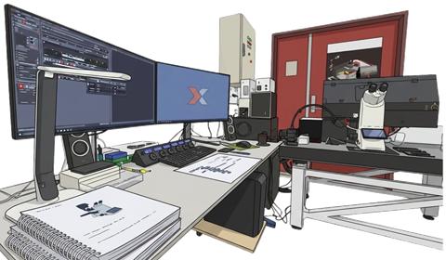
Contents
Prepare 1
File Save Preparation and Focus on cells 1
Setting the detection filters (Image Compass) 1
Tweak Acquisition Scanning parameters: 3
Using Navigator: Positions - Carrier – ROI Sections 3
Lightning Mode: Automate parameter setting to perform live deconvolution 5
Tau Separation: lifetime (τ) isolation or gating (Δτ >1 ns) 6
……………………………………………………………………………………………………………

Prepare
- Make notes of settings, rank your nicest images (link for a CCI-prepared template)
- Configuration tab: Bit depth 8<>16 bit, Glow Over, HyD’s in Count mode recommended
- Is optimal pixel size required for the experiment? Choose suited Objective and adjust pixel size to meet Nyquist criteria only when you need it
- Decide if, and which detector setting uses the transmitted light detection
- Know the dyes in your samples (spectral, lifetimes if available, stability)
  - Excitation/Emission spectra can be shown/uploaded in LAS-X dye database (Configuration tab)

File Save Preparation and Focus on cells
- Save Preparation: <PROJECTS> presets File Naming and file location
  - <.xlef> = lif+ extended metadata
  - In <New Project Defaults> set Project name: <YYYYMMDD_#UID-RefID (link to LabJournal)>
  - set <User defined name> #UID-RefID_TXT-describes-experiment_Channel-desciption
  - NO special characters (!@#$%^&*(){}?|\/=][><~`”;:) or SPACES, < 256 characters (with folder names)
  - <Autosave> to save multidimension data during acquisition (tick <OFF> while tweaking)
  - File Location: subfolders on E:\ImageDATA\<USER>\<DATE: YYYMMDD>
  - Make a <New Project> when switching samples (LAS-X add counters, Well-/ROI-name), re-save list frequently.
- Focus on cells
  - Transmission images usually work fine, low Mag 5x/10x, find a cs/well edge and move to cells, use a simple method or view by eye

Setting the detection filters (Image Compass)
- Start in Acquisition Mode (in Viewer: Split Channel / Activate Intensity Histogram)
- Optimize detector settings: Reuse/Create a detection sequence from file metadata or saved setting file => CHECK before use (LabJournal notes - link)
  - Hardware: Objective, filter ranges, laser (λ, power), HyD (type, mode, Gain, AI denoise),
  - Acq Settings: Pixel Size (Format & Zoom), Pix Dwell time (Speed-Galvo/Res, Bi-Dir), Pinhole, Acc/Avg, Z step, Z range, t interval-duration
- Search Dye, select and drag it onto the preferred HyD Detector (or drag onto empty space for automated setting), repeat for every dye
- Choose optimal HyD Type for Dye (order S1>X2>S3>X4>R5, start at shortest wavelength)
Figure1: HyD properties
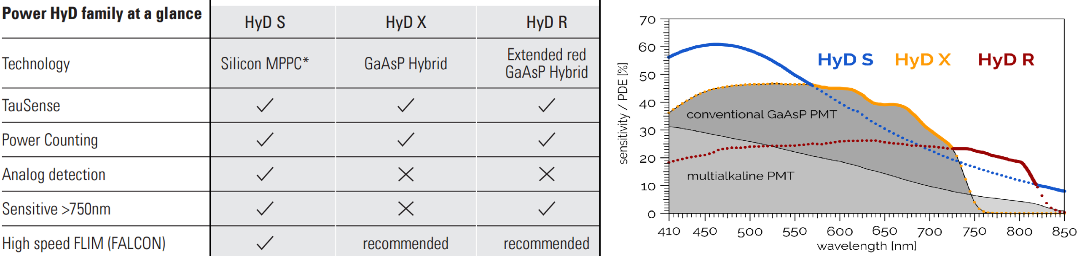
- Choose sequential mode to record dye (sets)
  - <+> Add a detector group, Ms(R) to reset a group
  - Line recommended, Frame allows different Acc or Avg per group
  - <Uncheck> to temporarily skip its acquisition
  - Avoid Dye Assistant, it resets filter ranges and does not include the HyD-R detector of the system (use it to get dye combination hints, do not <Apply>)
- Choose mode of the HyDs (analog/digital/photon count (FLIM)/reflection)
- Set Emission Filter Slider range
  - Fit emission spectra (shallow => ↓ Crosstalk & ↓ Signal), tweak Yield/Crosstalk by shifting the range
  - Ms(Clk)2 on slider to type λ-limits or Clk-n-Drag ends
  - No overlap with laser line (>8nm away) & AFC aborts when a filter ≥750 nm
- Set Excitation Laser λ
  - Fit excitation spectra – reduce Crosstalk by shifting from optimal, use PanelBox or Ms(Clk)2 the line to type
  - Inspect bleed/Crosstalk by varying Laser Intensity for the ‘donor’ channel, Intensity of the ‘acceptor’ Channel should not change, best evaluated in Viewer with Split channel & Histogram activated
  - Interactive elements open different setting GUIs (see numbered items in figure 2)
- Choose group that generates the Transmission channel (TransPMT >> <ON>, set its Gain/Offset)
- Set LUTs or channel coloring and save the setting in your data folder
  - Recommend to choose color blind-friendly sets that work well for presentation via beamers etc.)
  - Blue> Cyan, Red> Orange/Yellow, NIR> Magenta, TM > Grey; Explore Inverted for weak/sparse labels
  - Use CCI form (on desktop or CCI website) dedicated to structure documentation of settings, save as: Setting-UID in your data folder before filling the form. Setting comments, for example Z range, Z step, T Interval-duration, image-Q rank
Figure 2: Interactive GUI elements in the Image Compass
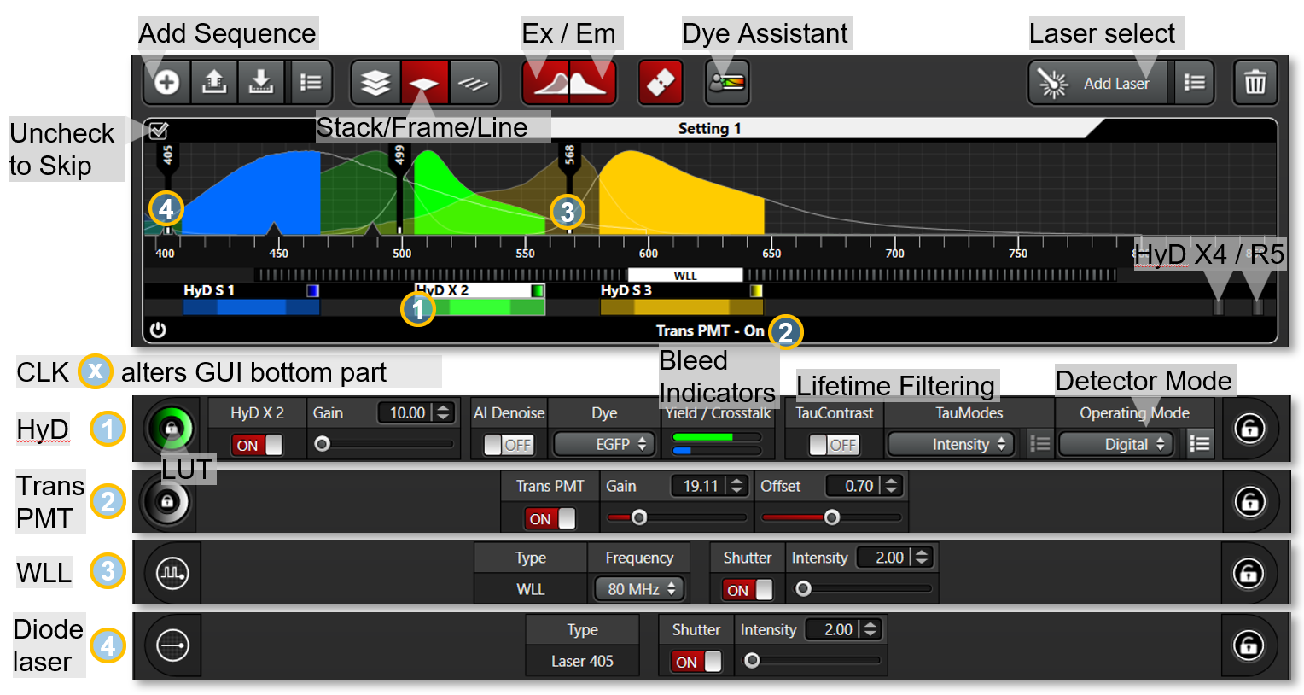

Tweak Acquisition Scanning parameters:

Start/Stop scanning
  - <FAST Live> to scan quickly (fast setting tweakable, it scans only the activate -white marked- Detector Group)
  - <Live> scans all channels as set (starts by Panelbox <Right Button>)
  - <Capture> takes image channels and omits other dimensions
  - <START> records all set dimensions
  - Compare images in <Viewer> by <+> to add another Project Image, linking synchs Zoom/Intensity changes, <X> to remove a parallel view

Acquisition Parameter setting
- Laser Intensity (use the Panel Box <Smart Intensity> or Ms(Clk)2 line to type)
- Scan Acquisition mode XY
  - Do not oversaturate: Bit type intensity maxima (8b>256, 16b> 65536), use Glow-Over LUT in viewer to evaluate
  - <Zoom in> prompts to make a ROI and Zoom into it
  - <Bidirectional X> scan @ double speed but striping/doubling artefacts can occur (changing with zoom, speed>700, format change etc.), it needs manual Phase-X correction
Figure3: Acquisition Scanner Setting
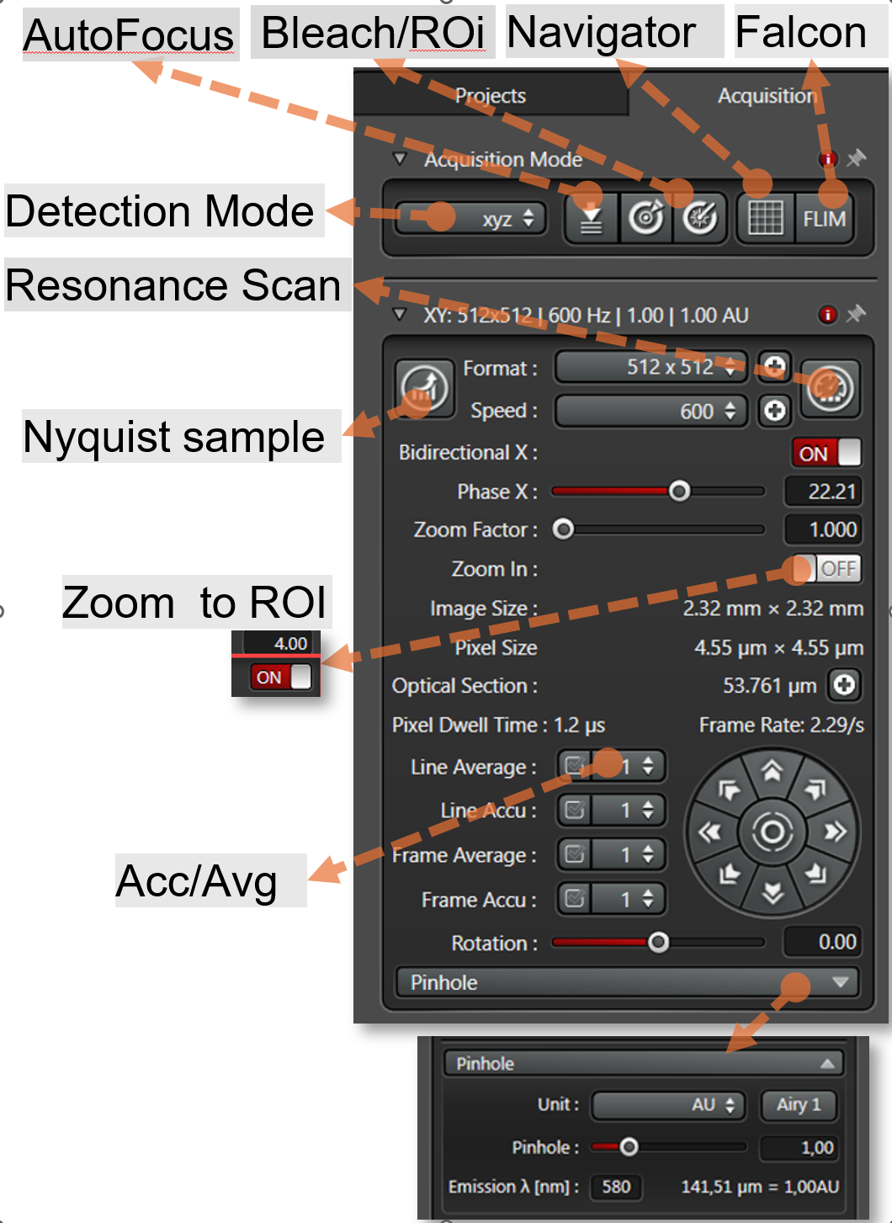
  - <Format> & <Zoom Factor> define XY Pixel Size (diffraction limit or not)
  - <Speed> defines Pixel Dwell Time: slower => signal↑ , the <Resonance Mode> locked high speed: needs higher laser powers, and avg/acc to improve S/N
  - <Pinhole> defines along with λ Optical section & Z step size (choose Airy 1 for the most important channel λ_{em})
  - <Rotation> orientate sample to optimally fit field
- Detector setting – signal pooling
  - <Gain> digitally enhances HyD signal – beware to go above 75 (not available in counting mode). TransPMT is more forgiving in its setting
  - <Offset> only available for TransPMT (use to tweak lowest signals), stay close to 0
  - <Avg> scans line/frame and retains the avg intensity: good for Gain, i.e. non-count modes
  - <Acc> accumulates line/frame intensities: perfect for count mode HyD
- Define Multidimensional imaging (Z, t, position, etc.=> Select Detection mode)
- Use <Navigator> to <Align> and use preset Carriers or define ROIs/positions.
- Check focus control (AFC, Autofocus in noise, make Focus Map in Navigator)
- Check timing

Using Navigator: Positions - Carrier – ROI Sections
Many of the acquisition GUI is available in the <Navigator> as well in grouped GUIs. Beam Path= image Compass, Scan Mode = XY scan parameters, Z stack, Time, positions GUIs are activated in the <Toolbar>. Generally, preparing imaging is easiest done in the acquisition tab while overview/position/tile/ROI functions are done in the navigator.
  - Ms(Clk)2 move to position and makes <Preview> image, Ms(Wheel) to Zoom.
  - <AFC> performs quite well in <Spiral Scan>, Ms(R) to select variants of the spiral scan
  - Avoid LUT pileup of all (tiles and) previews in the images listing by unchecking or deleting unnecessary previews/Tiles. Setting LUT for the active FOV is quite difficult otherwise.
  - <Split Channel View> for active position FOV, a GUI offers options to overlay. Switch back to <Stage Overview> to resume tile actions
  - <Task List> Check/Unchecking ROIs/wells can be per group as well. <START> will only record checked <Tasks>
  - <Save Overview…> saves the checked pre/over-views in <Projects>
  - <Mosaic Merge> generates a single large file in <Projects>
Figure 4: Navigator
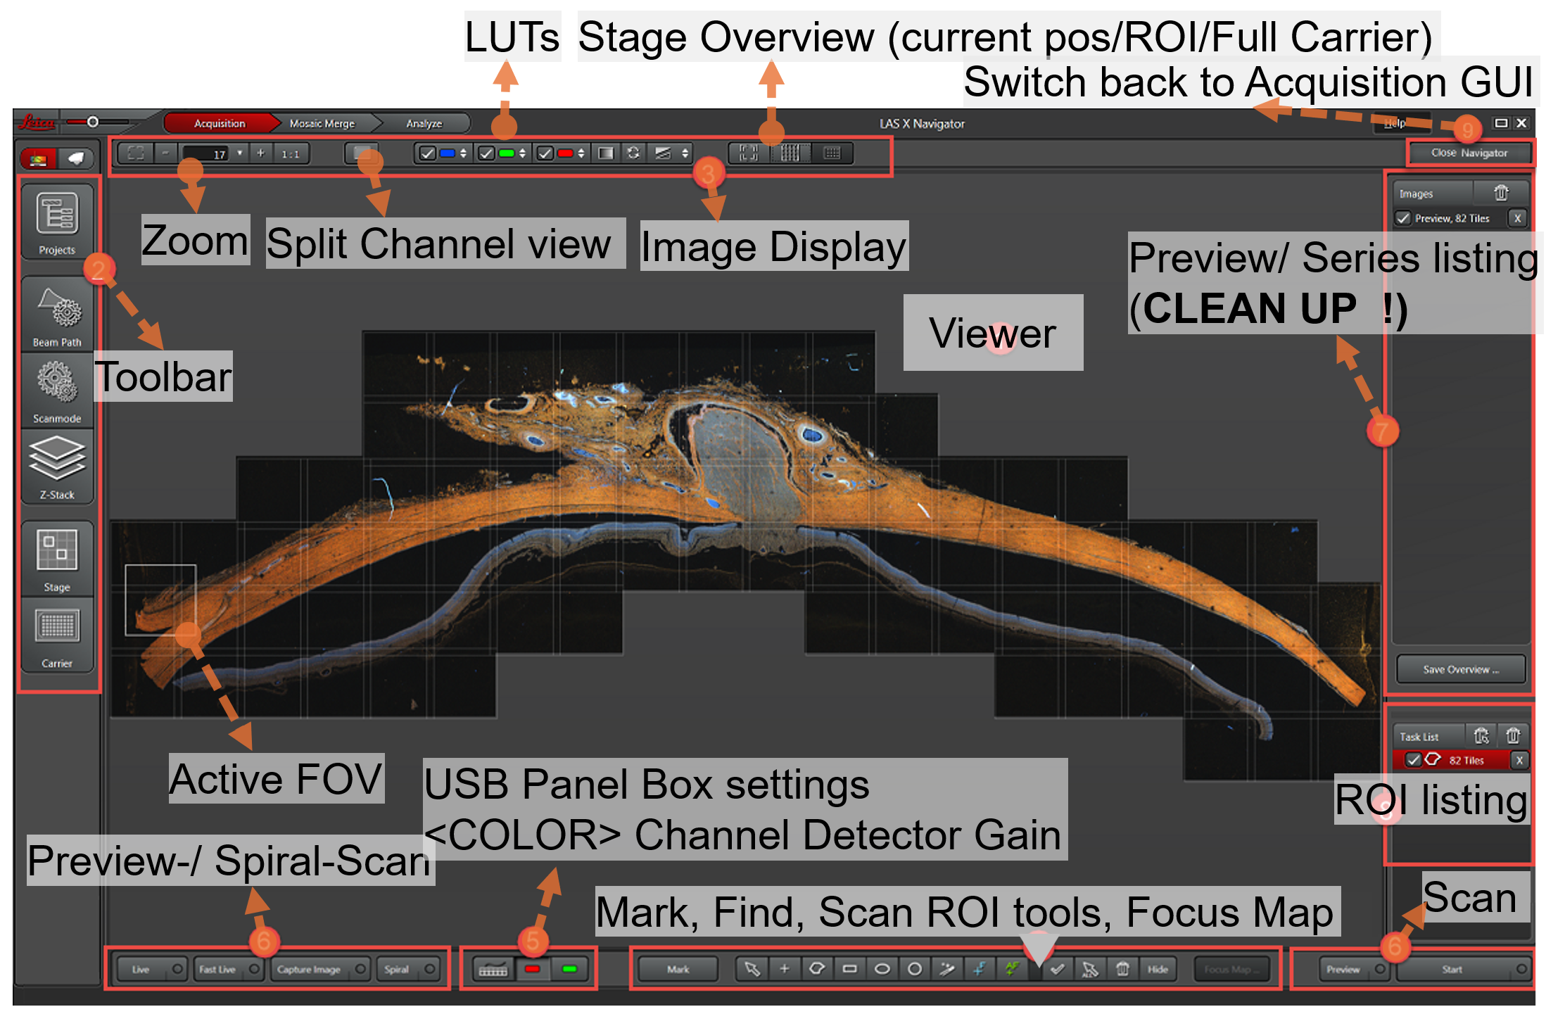

Focus MAP
- Make Spiral overview (low mag)
- Select ROI with drawing tools
- < > keep Drawing Tool active
- <+^{F}> to set focus XY position (remove by Select> Delete)
- <₊AF> to use in Timelapse / Stage (set <..on Demand> – everty x^{th} in time / position)
- <Focus Map…> to activate dialog and list XY
- <Set Z> Manual / Autofocus for active or all point(s) => Values Z/AFC are shown
  - OPTION: Shift Entire MAP in Z by defined offset (workaround to do asymmetric stacking)
  - CONTEXT Menu: Subtract Tool / Group Scan Regions / Paste Regions in Chambers etc.

Lightning Mode: Automate parameter setting to perform live deconvolution
- Autoparameter setting (unchain to adjust setting)
Figure 5: Lightning mode GUI
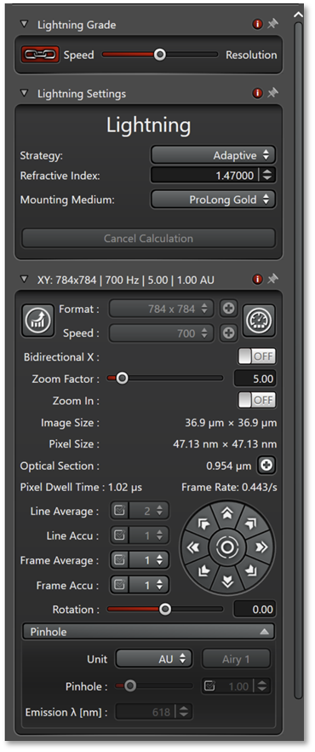
- LAS-X gets immersion media refractive index, estimates of imaging depth aberrations and psf’s for the channels from metadata
- Adaptive = generally better than Global
- Set the mounting media correctly (see table below)
  - Deconvolution is also available in the Process tab
Table 1: Lightning parameters
Auto parameter | Speed | <> | Resolution
Pinhole (AU) | ~ 1 | <> | Up to 0.3 AU (optimal √2 better than Abbe)
Pixel/ Z-step | .. | <> | Nyquist for given Pinhole
Speed | .. | <> | Decreases to improve light collection
Line Avg | ~1 | <> | Increases for better S/N
HyD Gain | Up to you | <> | Up to you
Laser % | Up to you | <> | Up to you

Table 2: Immersion media Refractive Indices
Name | Refractive index
VectaShield Vibrance | 1.47 (cured)
VectaShield Plus | 1.45
VectaShield Harset | 1.46 (cured)
VectaShield | 1.45
SlowFade Gold | 1.42
SlowFade Glass | 1.52
SlowFade Diamond | 1.42
ProLong Gold | 1.46
ProLong Glass | 1.51
Prolong Diamond | 1.46
Mowiol | 1.42
Fluoromount G | 1.42
Entellan | 1.49
DPX | 1.52
Canada Balsam | 1.52

Tau Separation: lifetime (τ) isolation or gating (Δτ >1 ns)
Table 3: Laser Frequency to interval conversion
Frequency (MHz) | Interval (ns)
80 | 12.5
40 | 25
20 | 50
10 | 100
5 | 200
2.5 | 400

Average Photon arrival time per pixel => assign Pix to an avg τ class

Prerequisites:
  - WLL (OPTION: notch filtered reference lines) / TauContrast <ON> / HyD in count mode
  - WLL pulse frequency should accommodate 3-4x the expected longest lifetime
  - Maximal Photon count rate should be Pulse rate ≅ 0.1 / laser pulse (Pixel Int Histo)/ 0.37 with Photon count filter
  - Tau output images are kept as separate channels in <Projects>
- TauContrast (analyse lifetime components in an emission block) > Intensity
  - OUTPUT: split viewer channel of emission block: Intensity channel and Lifetime channel (Spectral LUT-encoded τ, => spot peaking colors to identify abundant τ subsets )
- TauScan (set nr of images to extract τ -spieces)
  - OUTPUT: nr series with τ-range/nr, => spot the peak intensities in the image range
- GateScan (nr of preset Gates to estimate τ-species): <+> to add onther channel and slider set to define bounds
  - OUTPUT: series of defined τ-”bins” => spot differences in the extracted images
- TauGating: Set τ range based on Tau/Gate-Scan to put in a channel (unchecked range(s) will not be recorded => omit reflections, autofluorescence)
  - OUTPUT: Tau Images with selected τ characteristics (and omitted τ species from the recorded images)
- TauSeparation (use τ estimates from Tau/Gate-Scan, <+> and define in slider, or allow algorithm to extract them, <Find>)
  - OUTPUT: Tau Images with defined τ characteristics

