Lumencor web site http://lumencor.com/products/spectra-x-light-engine/
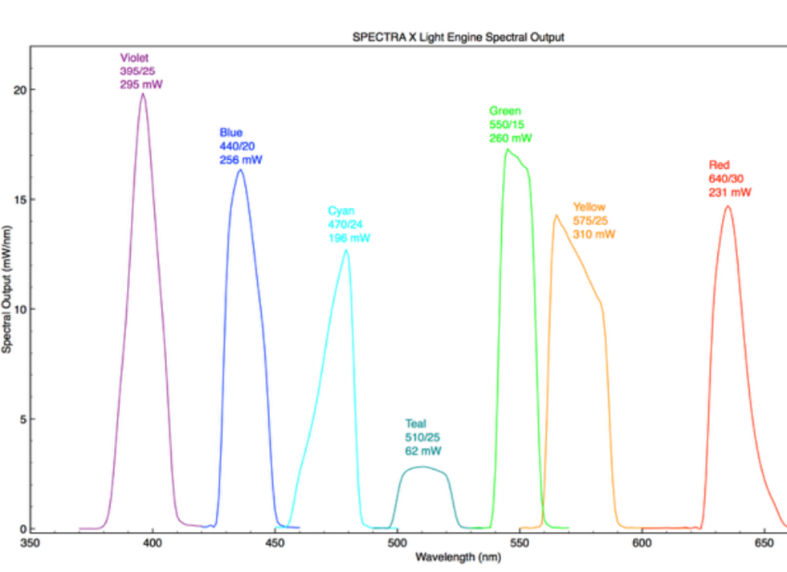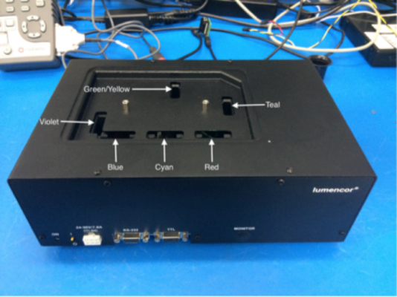
Available filters:
- Violet: 395/25
- Blue: 440/20
- Cyan: 470/24
- Red: 640/30
- Teal: 510/25
- Green/Yellow: 550/15 or 575/27 (exchange filters for optimal excitation)
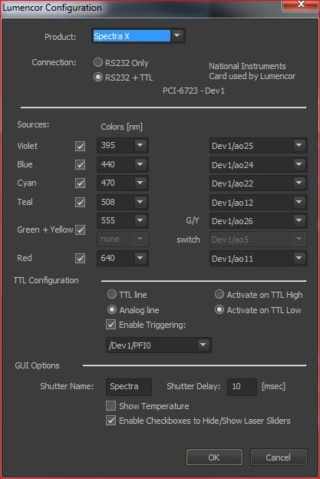
Troubleshoot:
- When light remains on all the time, check cable connection in the lumencor configuration settings (see figure)
- When light is not tuneable by software miscommunication via the COM port likely occurs (in: >Device select SpectraX > settings => set COM port to 2)

mCherry imaging:
575/25 filter should be in the SpectraX light house (extra filter is placed below the cover in the light house)
Place in the Green/Yellow (GY) slit grip facing G/Y marking (does not fit otherwise)
- Select in config : 575 nm, check connections.
- Use CFP/YFP/mCherry filter block in lower turret
- Image as usual (use ND4 and 8 filters to tune the LED light at lower levels)

